INSTRUCTIONS FOR FORMATTING THE PROCEEDINGS EXTENDED ABSTRACTS OF THE IWADA 2023

First Author1, Second Author2, Third Author3

¹First author affiliation
Address, City and Postcode, Country
e-mail and web page

²Second author affiliation
Address, City and Postcode, Country
e-mail and web page

³Third author affiliation
Address, City and Postcode, Country
e-mail and web page

Abstract. The purpose of these instructions is to serve as a guide for formatting extended abstracts to be published in the Proceedings of the IWADA 2023. The abstract should describe the objectives, the methodology and the main conclusions of the paper. It should contain neither formulae nor reference to bibliography.
Keywords: component; formatting; style; styling; insert… (up to 5 keywords)

1. Introduction
The proceedings of the IAWDA 2023 will be published in Adobe™ PDF format. The extended abstracts must be formatted strictly according to these instructions. The present file can be used as a template for Microsoft Word™ users, try and use the provided styles for Paper Title, Headings, Section Body, Equations, Captions, etc. This document should be used as a formatting guide to users of other text processing software.

2. Text format
The manuscripts should be written in English, typed in A4 size pages, using font Times New Roman, size 11, except for the title, author’s affiliation, abstract and keywords, for which particular formatting instructions are indicated above. Single space between lines is to be used throughout the text.
All the pages must have a top margin of 4.3 cm, bottom margin of 4.4 and all the other margins (left and right) must have 2.5 cm.
The body of the text must be justified. The first line of each paragraph must be indented by 0.5 cm. Sufficient information must be provided directly in the text, or by reference to widely available published work. Footnotes should be avoided.
All the symbols and notation must be defined in the text. Physical quantities must be expressed in the SI (metric) units. In order to avoid units braking in the next line use Ctrl+Shift+space between the numerical value and the unit. Mathematical symbols appearing in the text must be typed in italic style.

Section and subtitles
The section headers and sub headers must be aligned at left, typed with Times New Roman, size 11, bold style font, with the first letter capitalized and numbered consecutively. They must be numbered using Arabic numerals separated by points. The current MS Word template provides automatic numbering. No more than 3 sublevels should be used. One single line size 10 must be included above each section title/subtitle (use the Section Body style).

Construction of references
References must be listed at the end of the paper. Do not begin them on a new page unless this is absolutely necessary. Authors should ensure that every reference in the text appears in the list of references and vice versa. Indicate references by [1] or [2,3] in the text.
Some examples of how your references should be listed are given at the end of this template in the ‘References’ section, which will allow you to assemble your reference list according to the correct format and font size.

Mathematical equations
The mathematical equations must be indented by 0.5 cm from the left margin. They must be typed using Times New Roman, italic, size 10 pt. font. Arabic numerals must be used as equation numbers, enclosed between parentheses, right-aligned, as shown in the examples below. Equations should be referred to either as “Eq. (1)” in the middle of a phrase or as “Equation (1)” in the beginning of a sentence. Symbols used in the equations must be defined immediately before or after their first appearance.
One blank line must be included above and below each equation.

a + b= y (1)

(2)

Tables
Tables should be placed in the text as close as possible to the point they are first mentioned and must be numbered consecutively in Arabic numerals. All tables should be numbered with Arabic numerals. Every table should have a caption. Only horizontal lines should be used within a table, to distinguish the column headings from the body of the table, and immediately above and below the table. Tables must be embedded into the text and not supplied separately.
Tables must be referred to either as “Tab. 1” in the middle of a phrase or as “Table 1” in the beginning of a sentence. The tables themselves as well as their titles must be centered in the breadth-wise direction. The titles of the tables should not be longer than 3 lines, centered and use Times New Roman size 11. The font style and size used in the tables must be similar (both in size and style) to those used in the text body, font size 10. Units must be expressed in the S.I. (metric) system. Explanations, if any, should be given at the foot of the tables, not within the tables themselves.
One blank line must be left before and after each table. Below is an example which the authors may find useful.

Table 1 – An example of a table.

An example of a column heading | Column A (t) | Column B (t)
And an entry | 1 | 2
And another entry | 3 | 4
And another entry | 5 | 6

Figures
Figures should be placed in the text as close as possible to the point they are first mentioned and must be numbered consecutively in Arabic numerals. Figures must be referred to either as “Fig. 1” in the middle of a phrase or as “Figure 1” in the beginning of a sentence. The figures themselves as well as their captions must be centered in the breadth-wise direction. The captions of the figures should not be longer than 3 lines, centered and use Times New Roman size 11.
The caption for the data symbols as well as the labels for each curve should be included into the figure. Lettering should be large enough for ease reading. All units must be expressed in the S.I. (metric) system. One blank line must be left before and after each figure.

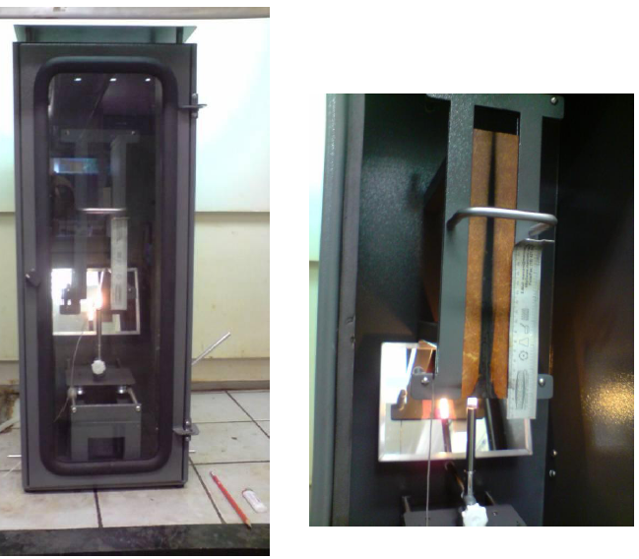
(a) (b)

Figure 1 – An example of figure (a) first picture; (b) second picture.

Color figures and high quality photographs can be included in the paper. To reduce the file size and preserve the graphic resolution, figures must be saved into GIF (figures with less than 16 colors) or JPEG (for higher color density) files before being inserted in the manuscript.

Acknowledgment
This optional section must be placed before te list of references.

References
The template will number citations consecutively within brackets [1]. The sentence punctuation follows the bracket [2]. Refer simply to the reference number, as in [3]—do not use “Ref. [3]” or “reference [3]” except at the beginning of a sentence: “Reference [3] was the first ...”
Number footnotes separately in superscripts. Place the actual footnote at the bottom of the column in which it was cited. Do not put footnotes in the reference list. Use letters for table footnotes.
Unless there are six authors or more give all authors’ names; do not use “et al.”. Papers that have not been published, even if they have been submitted for publication, should be cited as “unpublished” [4]. Papers that have been accepted for publication should be cited as “in press” [5]. Capitalize only the first word in a paper title, except for proper nouns and element symbols.
For papers published in translation journals, please give the English citation first, followed by the original foreign-language citation [6].

- G. Eason, B. Noble, and I.N. Sneddon, “On certain integrals of Lipschitz-Hankel type involving products of Bessel functions,” Phil. Trans. Roy. Soc. London, vol. A247, pp. 529-551, April 1955. (references)
- J. Clerk Maxwell, A Treatise on Electricity and Magnetism, 3rd ed., vol. 2. Oxford: Clarendon, 1892, pp.68-73.
- I.S. Jacobs and C.P. Bean, “Fine particles, thin films and exchange anisotropy,” in Magnetism, vol. III, G.T. Rado and H. Suhl, Eds. New York: Academic, 1963, pp. 271-350.
- K. Elissa, “Title of paper if known,” unpublished.
- R. Nicole, “Title of paper with only first word capitalized,” J. Name Stand. Abbrev., in press.
- Y. Yorozu, M. Hirano, K. Oka, and Y. Tagawa, “Electron spectroscopy studies on magneto-optical media and plastic substrate interface,” IEEE Transl. J. Magn. Japan, vol. 2, pp. 740-741, August 1987 [Digests 9th Annual Conf. Magnetics Japan, p. 301, 1982].
- M. Young, The Technical Writer’s Handbook. Mill Valley, CA: University Science, 1989.

